CSA 283: Final

Name: ______________________________________ Section: _____ _____

Please write legibly. Ask questions if something is unclear. Write down any assumptions you make.

Exam is printed on both sides of the page!

Keep your answers concise. Write the minimum that is necessary when explaining.

- Consider the network diagram shown in the supplemental handout. The diagram depicts the following:

- Four end systems labeled A, B, C, and D
- Two switches labeled S1 And S2
(Switch interfaces are labeled 1, 2 and 3 for each switch)
- Five routers labeled R1, R2, R3, R4, and R5.
  - The interfaces of R2 are labeled 1 – 3
  - Router R1 is performing NAT

Information held at various nodes is given in tables on the page attached to the diagram.

Use the diagram and tables to answer the following questions. Write no more than one sentence for “Why or Why not?” questions.

Consider a message being sent from host A to host C and the segments, datagrams, and frames that will be generated to carry the message.
- The socket on A that is being used to send messages has a port number of 5600.
- The port number of the socket being used on C to receive the message is 80.

    - Suppose A knows the name of computer C is www.netnews.com. What protocol would A use to determine the IP address of C?

    - What protocol would A use to determine the MAC address of C? (3 Points)

    - Would A need to use ARP to find the MAC address of S1? Why/why not?(4 points)

    - Based on the information shown to be held by A, can A put together a frame that will be received by R1? Why or why not? (4 points)

    - When A is sending a packet to C, will the network interface adapter of B receive the frame that is sent by A to R1? Why or why not? (4 points)

    - Can A transmit a frame to R1 via S1 while R1 is transmitting a frame to B via S1 without colliding? Why or why not? (4 points)

    - Suppose S1 was a hub instead of a switch. Would A be able to transmit a frame to R1 via S1 while R1 is transmitting a frame to B via S1 without colliding? (3 points)

    - When a datagram travels from A to C, what will the source and destination physical addresses be in the frame that carries it from A to R1? (4 points)

Source MAC: ____________________________________

Destination MAC: ____________________________________

    - When A is sending a datagram to C, what will be the destination IP address and port number in the datagram/segment as it travels between A and R1? (4 points)

Destination IP ____________________________________

Destination Port ____________________________________

    - When A is sending a datagram to C, what will be the source IP address and port number in the datagram /segment as it travels between A and R1? (4 points)

Source IP ____________________________________

Source Port ____________________________________

    - Suppose the subnet between R1 and R2 has a MTU of 496 bytes. Further suppose the original datagrams sent by A have a length of 1496 bytes. Fill in the characteristics for the fragments that would be created to carry the data in the datagram with an ID of 34 . Assume the IP header is 20 bytes long for all fragments. (8 points)

Original Datagram:
 | Length = 1496 | ID = 34 | Fragflag = 0 | Offset = 0

Fragments:
 | Length = | ID = | Fragflag = | Offset =

 | Length = | ID = | Fragflag = | Offset =

 | Length = | ID = | Fragflag = | Offset =

 | Length = | ID = | Fragflag = | Offset =
    - When a datagram travels from A to C, what will the source and destination physical addresses be in the frame that carries it from R1 to R2? (4 points)

Source MAC: ____________________________________

Destination MAC: ____________________________________

    - Based on the forwarding table given for R2, when A is sending a packet to C, will it forward the packet to R3 or R4? (4 points)

    - Give the Classless InterDomain Routing (CIDR) notation for the first subnet identified by forwarding table of R2. Indicate approximately how many hosts each sub-net could contain. (4 points)

CIDR notation Approx. Number of Hosts

________________________ __________

    - When A is sending a datagram to C, what will be the source IP address and port number in the datagram /segment as it travels between R5 and C? (4 points)

Source IP ____________________________________

Source Port ____________________________________

    - When A is sending a datagram to C, what will be the destination IP address and port number in the datagram /segment as it travels between R5 and C? (4 points)

Destination IP ____________________________________

Destination Port ____________________________________

    - Based on the information shown to be held by R5, can R5 put
together a frame that will be received by C? Why/ why not? (4 points)

    - If you answered no to the previous question, describe the process that would take place before R5 could construct a frame to send to C.
(6 points)

    - When R5 is sending a frame to C, will the interface adapter of D receive the frame? Why/why not? (4 points)

    - After R5 has sent a frame to C, would the switch table for S2 be updated? If so what entries would be added to the switch table? (4 points)

    - If C sends a reply back to A, what will the source IP address and source port number be in the datagram/segment as it travels between C and R5? (4 points)

Source IP ____________________________________

Source Port ____________________________________

    - When C sends a reply back to A, what will be the destination IP address and port number in the datagram/segment as it travels between R2 and R1? (4 points)

Destination IP ____________________________________

Destination Port ____________________________________

    - In what way will the IP addresses of C, D, and the R5 adapter with a MAC address of 51-3D-CA-CD-04-98 be related? Why?(5 points)

    - Would you expect C, D, and the R5 to use the same Intra-AS Routing protocol? Why or why not? (3 points)

    - How will the MAC addresses of C, D, and the R5 adapter with a MAC address of 51-3D-CA-CD-04-98 be related? (3 points)

    - Based on the diagram, how many subnets does R5 belong to? (3 points)

- Assume the following datagrams were receive at the same moment:

Segment One Characteristics:
- Source address: IP1
- Source port 100
- Destination address: IP2
- Destination port 400.
Segment Two Characteristics:
- Source address: IP1
- Source port 100
- Destination address: IP3
- Destination port 400.

  - Would it be possible for these two segments to have been transmitted using TCP? Why or why not? If it is possible, could the two segments be received by the same socket? (6 points)

  - Assuming that both packets reach their final destination and are transmitted using UDP, will the two UDP packets be received by the same socket? Why or why not? (6 points)

  - What mechanism(s) does the TCP protocol use to detect duplicate packets? Does UDP use this mechanism? (6 points)

  - What mechanism(s) does the TCP protocol use to detect lost packets? Does UDP use this mechanism? (6 points)

  - What mechanism(s) does the TCP protocol use to detect corrupt packets? Does UDP use this mechanism? (6 points)
  - Give definitions for the following terms using one or two sentences. If the term is an acronym, also state what the letters in the acronym stand for and give a definition. Use no more than two sentences to describe the term.

a. Jam Signal (6 points):

b.CSMA/CD (6 points):

c. Receive Window (6 points):

d. DHCP (6 points)

e. Elastic Application (6 points)

  - Using node A in Figure 1 as the source, show the step by step results of link state (LV) algorithm to find the shortest path to all other nodes. Show the members of N, the predecessor of each destination, and the shortest known distance to each destination after the initialization phase of the algorithm and after each iteration of the main loop.
(21 points)
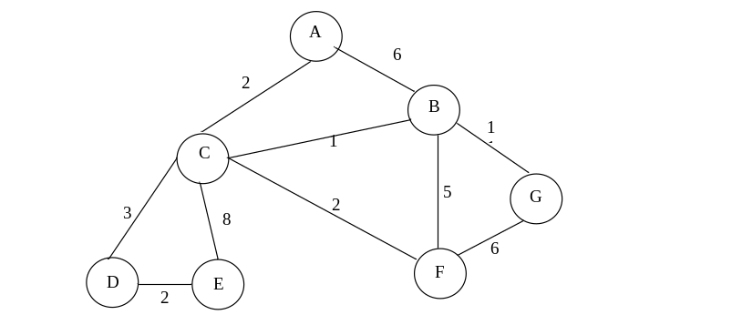
Figure 1: Network Graph

  - Write down the shortest path to all destinations in Figure 1 using the predecessor data in the table you created in the previous question. In other words drawn the minimum spanning tree (MST). (7 points)

  - Consider the following scenario:

An application running on jerry.npr.org needs to determine the IP address of sara.uc.edu in order to make a TCP connection. In the following, assume that all nodes cache DNS records and all DNS caches contain the minimum information necessary to function. DNS server names are as follows:

Top Level Domain DNS server, edu: dns.tld.edu
Top Level Domain DNS server, org: dns.tld.org
Local Name server, uc: local.uc.edu
Local Name server, npr: local.npr.org
Authoritative DNS, npr: dns.npr.org
Authoritative DNS, uc: dns.uc.edu
Root DNS server: dns.root

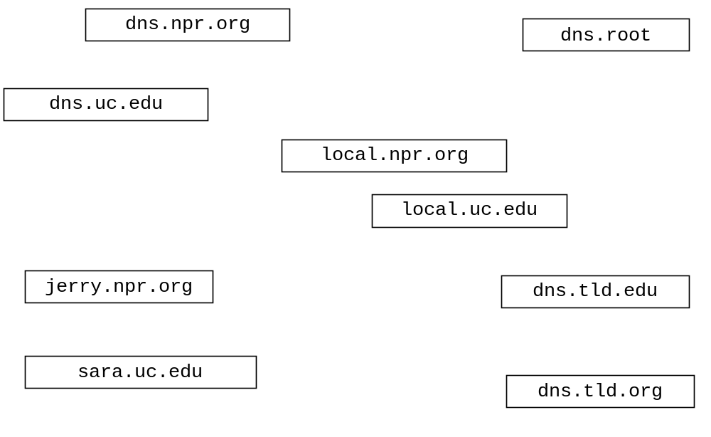Draw arrows labeled with numbers to indicate the order of queries and responses sent before jerry.npr.org receives the IP address of sara.uc.edu The first query sent by jerry.npr.org is handled recursively. Assume all other queries are handled iteratively.
(24 points)

  - Complete the Server below. Do not worry about handling exceptions. Allow the main method to throw them to the OS. (40 points)
- Clients send an unknown number of floats (4 bytes each) to the server in a single datagram using UDP. No additional information is contained in the Datagram. The maximum number of floats that can be sent in a single datagram is 100.
- The Server determines the number of floats in the datagram and calculates the sum of them and sends the sum back to the client as a double (8 bytes) using UDP.
- The Server listens on port number 7777.
- The Sever closes down any Client specific streams and sockets after sending the sum to a Client.
- The Server never closes.

import java.io.*;
import java.net.*;

public class UDPSumServer {

public static void main(String[] args) throws Exception
{

  - Complete the Server class on the next page. Do not worry about handling exceptions. Allow the main method to throw them to the OS. (40 points)

- Clients send groups of four doubles using TCP.
- If all numbers received are positive, the Server calculates the sum of the set of four and sends the sum back to the client that sent them as a double. The server keeps the connection with the client open in order to receive another set of numbers.
- If the Server receives a negative number from a client, it will immediately close the connection with the client without sending back a sum and start waiting for a connection from another client.
- The Serves handles clients sequentially (no multi-threading).
- After serving ten clients, the server closes down.
- The Server listens on port number 7777.
- Close all open streams and sockets before the program exits.
import java.io.*;
import java.net.*;

public class TCPSumServer {

public static void main(String[] args) throws Exception
{

